Amazon E-Commerce Data Analysis & Revenue Insights (MySQL)

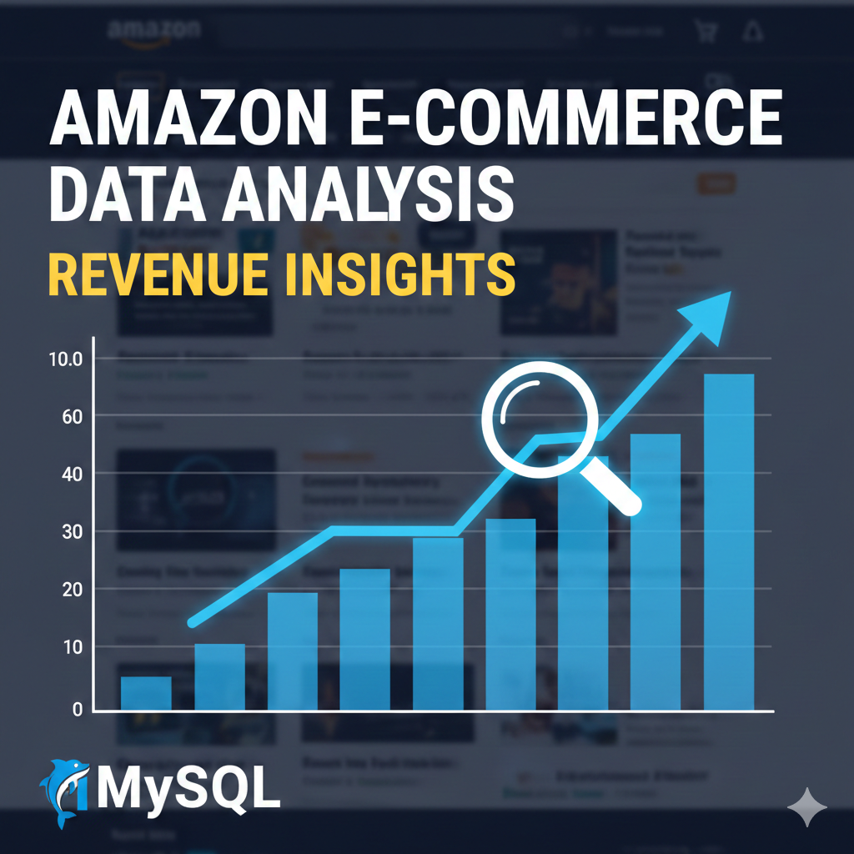

Mauzzam Shaikh
Date : 20-02-2026

PROJECT OVERVIEW
This project analyzes an Amazon sales dataset containing 100,000 transaction records to uncover key business insights. The data was cleaned and processed using SQL, ensuring accuracy and consistency for analysis. The study focuses on revenue performance, customer behavior, product trends, geographic distribution, and payment patterns. The objective is to support data-driven decision-making through structured queries and analytical reporting.

MAIN GOALS
- To clean and preprocess the Amazon sales dataset to ensure accurate and reliable analysis.
- To analyze total revenue, order volume, and average order value to measure overall business performance.
- To identify top-performing products, categories, and sellers based on sales and revenue.
- To evaluate customer purchasing behavior, including top customers and preferred payment methods.
- To analyze geographic performance by identifying high-revenue cities and states.
- To examine monthly sales trends to understand growth patterns and seasonal performance.

DATABASE DESIGN
The database for the Amazon Sales Analysis System is designed using a relational model to ensure data accuracy, integrity, and efficient analytical querying. It organizes transactional sales data into structured attributes such as orders, customers, products, sellers, and payment information.
The design supports business intelligence analysis by enabling revenue tracking, customer behavior evaluation, product performance measurement, and time-based trend analysis. Proper data types, primary keys, constraints, and indexing techniques are implemented to maintain consistency and improve query performance.
The schema is optimized for analytical reporting and dashboard creation, allowing structured insights into sales performance, geographic distribution, and operational efficiency.

- QUERIES:
- CREATING DATABASE

- Input

- Output

- INSIGHT: A separate database is created to efficiently manage and analyze Amazon sales data.

- CREATING TABLE
- Question: Create a table named employees to store details of restaurant staff. Include columns for employee ID, employee name, and employee role with appropriate constraints such as primary key and NOT NULL.

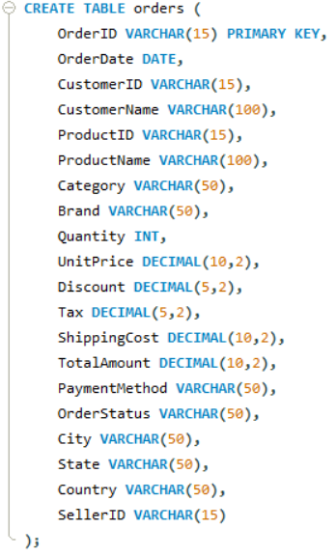
- INPUT

- OUTPUT
- INSIGHT: Ensures structured storage of employee data with a unique identifier and supports linking staff to order processing activities.

- INSERTING VALUES
- QUESTION : Inserting values in each column.

- INPUT: The orders table in the amazon database was populated using a Kaggle dataset containing 100,000 records, ensuring large-scale transactional data for accurate sales analysis and business insights.

- OUTPUT
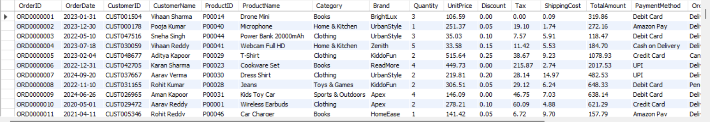

SQL ANALYTICAL QUESTIONS & QUERIES
Question 1 What is the total revenue generated from all orders?
Query:
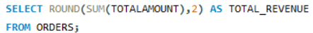
Output:
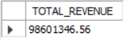
Insight: The total revenue generated from all orders is ₹9,860,136.56, indicating strong overall sales performance.

Question 2 How many total orders were placed during the dataset period?
Query:
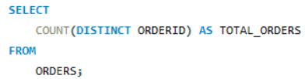

Output:
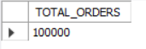
Insight: The business processed 100,000 total orders, reflecting a high transaction volume and strong customer activity.

Question 3 Which category gives highest average order value?
Query:
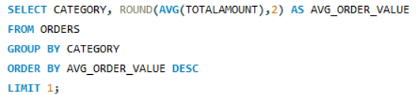

Output:
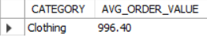

Insight: Clothing has the highest average order value at ₹996.40, indicating customers spend the most per order in this category.

Question 4 Which product generated the highest total revenue?
Query:
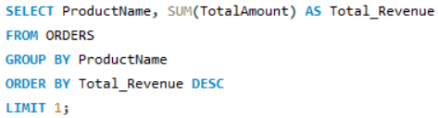

Output:
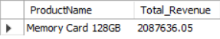
Insight: Memory Card 128GB is the top revenue-generating product, contributing ₹2,087,636.05 in total sales.

Question 5 Which category contributes the highest total sales?
Query:
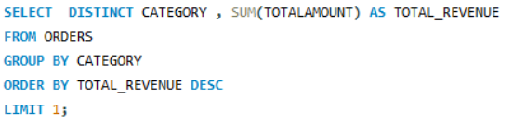
Output:
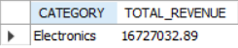
Insight: Electronics is the highest revenue-generating category, contributing ₹16,727,032.89 in total sales, making it the primary driver of overall revenue.

Question 6 Which city generates the highest revenue?
Query:
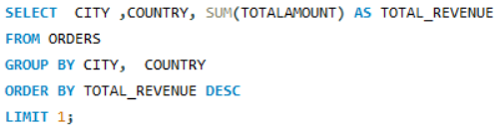
Output:
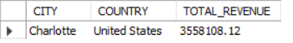
Insight: Charlotte, United States is the top revenue-generating city, contributing ₹3,558,108.12 in total sales.

Question 7 Who are the top 10 customers by revenue?
Query:
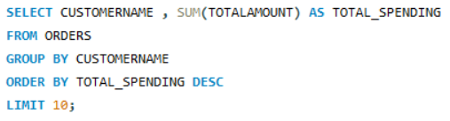
Output:
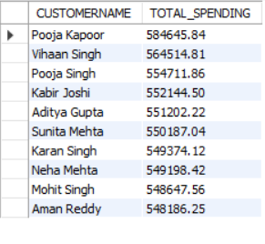
Insight: Pooja Kapoor is the highest-spending customer with ₹584,645.84, indicating strong contribution from repeat or high-value purchases among top customers.

Question 8 What is the monthly revenue trend?
Query:
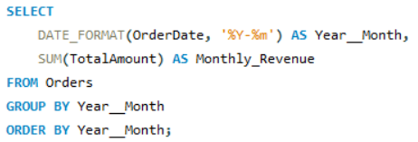

Output:
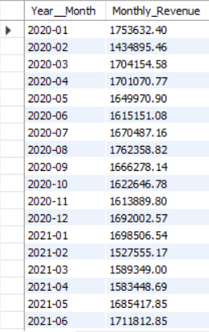
Insight: Monthly revenue remains relatively stable between ₹1.4M–₹1.75M, with peak performance in January 2020 (₹1.75M) and a slight dip in February 2020 and February 2021, indicating mild seasonal fluctuations.

Question 9 Which seller generated the highest overall sales?
Query:
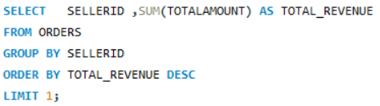
Output:
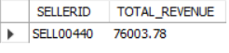
Insight: SELL00440 is the top-performing seller, generating ₹76,003.78 in total revenue, making them the highest revenue contributor among all sellers.

Question 10 Calculate month-over-month revenue growth.
Query:
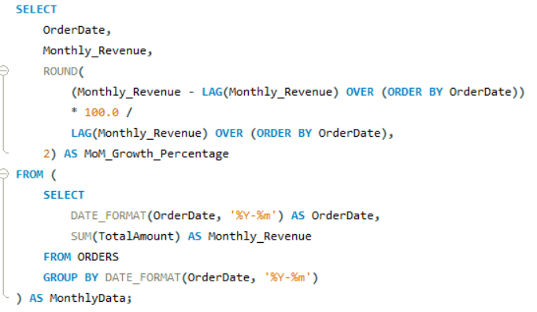

Output:
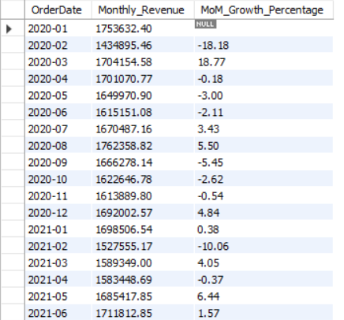
Insight: Revenue shows noticeable fluctuations, with the sharpest decline in February 2020 (-18.18%) and strong rebounds in March 2020 (+18.77%) and May 2021 (+6.44%), indicating short-term volatility but overall recovery trends.

Question 11 Which payment method is used most frequently?
Query:
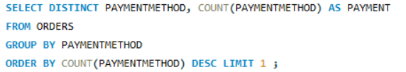
Output:
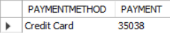
Insight: Credit Card is the most preferred payment method with 35,038 transactions, indicating strong customer trust in card-based payments.

Question 12 What percentage of orders are successfully delivered?
Query:
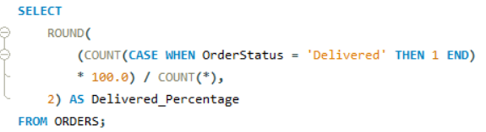
Output:
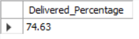
Insight: Approximately 74.63% of orders were successfully delivered, indicating a strong but improvable fulfillment performance.

Amazon E-Commerce Data Analysis & Revenue Insights (MySQL) – Project Summary
This project focuses on analyzing Amazon e-commerce sales data using MySQL to extract meaningful business insights related to revenue, customers, products, sellers, and order performance.
The dataset consists of 100,000+ orders, generating total revenue of ₹9.86M+. Through advanced SQL queries including GROUP BY, JOINs, CTEs, Window Functions (LAG), Aggregations, and CASE statements, key performance indicators (KPIs) were calculated and analyzed.
Key Insights:
- Electronics emerged as the highest revenue-generating category.
- Memory Card 128GB was the top-selling product by revenue.
- Charlotte (USA) generated the highest city-wise revenue.
- Credit Card was the most preferred payment method.
- 74.63% delivery success rate indicates strong order fulfillment.
- Monthly revenue showed seasonal fluctuations with noticeable MoM growth variations.
Skills & Tools Used:
- MySQL
- Data Aggregation & Cleaning
- Window Functions (LAG for MoM Growth)
- KPI Reporting
- Business Insight Generation
This project demonstrates strong SQL proficiency, data analysis capability, and the ability to convert raw transactional data into actionable business insights.

Business Value

This project delivers significant business value by converting raw e-commerce transaction data into actionable insights that support strategic decision-making. By identifying top-performing categories like Electronics, high-revenue products such as Memory Card 128GB, and leading revenue-generating cities like Charlotte, the analysis helps the business focus marketing, inventory, and sales efforts on the most profitable areas. It also highlights high-value customers to support targeted marketing and loyalty strategies, while revealing Credit Card as the most preferred payment method to optimize payment partnerships and promotions. Additionally, the 74.63% delivery success rate provides insight into operational efficiency, and monthly revenue with MoM growth analysis enables better forecasting, seasonal planning, and performance monitoring. Overall, the project supports improved profitability, customer retention, and data-driven business decisions.

